SIMATS ENGINEERING (SAVEETHA SCHOOL OF ENGINEERING)
Department of Computer Science and Engineering
C01_AT2 — DATA INTERPRETATION EXERCISE

Course Code: | DSA06 | Course Title: | Data Handling and Visualization
CO Assessed: | CO1 –Apply (BL3) | Assessment: | Assessment Tool 2 – Data Interpretation
Weightage: | 20% of CIA | Total Marks: | 20(2 Questions × 20 Marks)
CO1 Statement: | Understand the fundamental concepts, principles, and techniques of data visualization.(BL2)
Student Name: | Janani Priya G | Reg. No.: | 192324041
Section / Batch: | 2023 Btech AI&DS / SLOT C | Date: | 28/07/2026

Code of Conduct
I Janani Priya G / 192324041 (Name / Reg No) certify that this submission is my original work and that I have adhered to the guidelines specified for this assessment. I understand that any violation of academic integrity rules will result in disciplinary action.

Signature of the Student: _________________________

Instructions
- This test contains 2 questions, each carrying 10 marks. Total: 20 Marks.
- No negative marking. Unanswered questions carry zero marks.

Annexure A – DATA INTERPRETATION

PROBLEM 03 (A):Classify each of the three columns by data type:

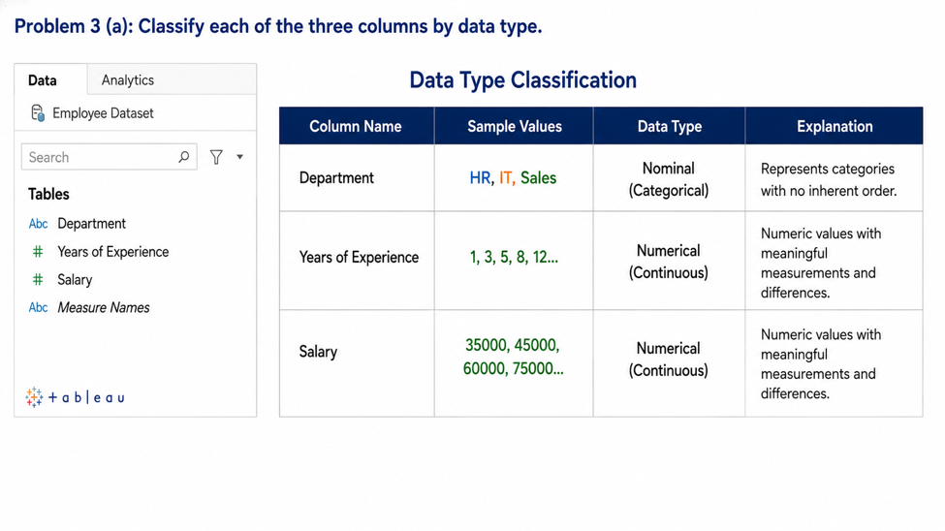

PROBLEM 03 (B) AESTHETIC MAPPING :

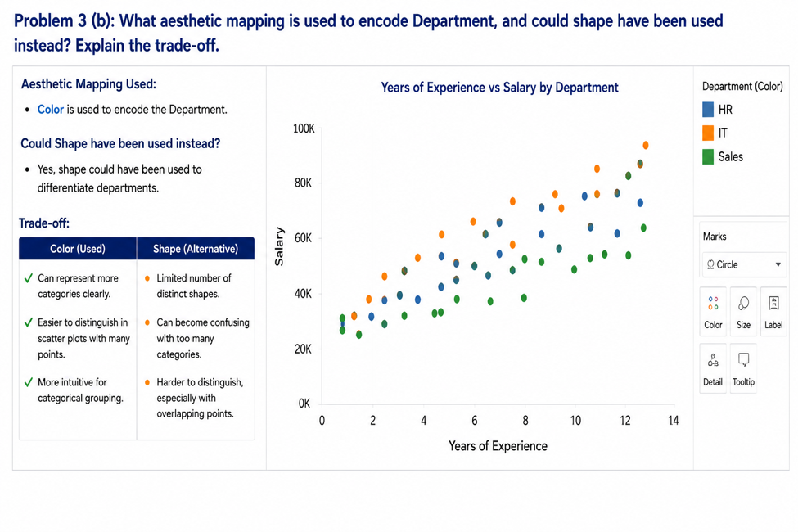

PROBLEM 03 (C) CLUSTER MAPPING_IT EMPLOYESS:

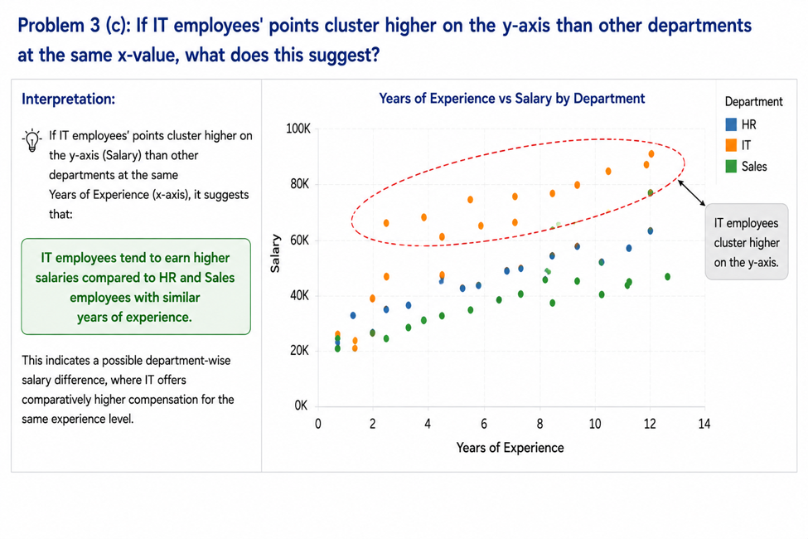

PROBLEM 13 RADAR CHART:

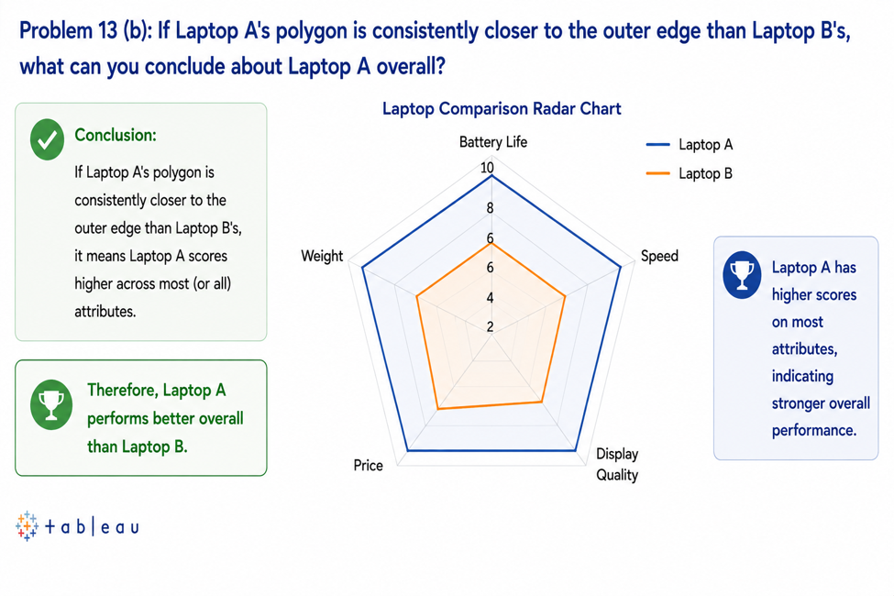

Faculty In-charge | Course Coordinator | Head of Department
Signature: _______________ | Signature: _______________ | Signature: _______________
Date: ___________________ | Date: ___________________ | Date: ___________________

